
NORTHERN EDUCATION DIVISION MOCK EXAMINATION
2026 JUNIOR CERTIFICATE EXAMINATION
PHYSICS
(100 marks)
Friday, 27th March, 2026 Subject Number: J164
Time Allowed: 2 hours
8:00-10:00am

Questions  number | Tick if  Answered | Do not write in these columns
1-20
21
22
23
24
25
26
27
28
29
30
31
32
33
Instructions.
- This paper contains 13 printed pages. Please check!

- Write your examination number/name at the top of each page.

- This paper has three sections A, B and C. In section A, encircle the letter representing the correct answer to each question. Section B and C should be answered in the spaces provided.

- Answer all the thirty-three questions.

- Use of standard electronic calculators is allowed.

- In the table provided on this page, tick against the question number you have answered.

- Hand in your paper to the invigilator when time is called to stop writing.

Section A (20 marks)
Answer all the twenty questions in this section
Encircle the letter representing the correct answer.

- The amount of electric current in a circuit can be measured by using
- An Ohmmeter.
- An ammeter.
- A voltmeter.
- A bulb.

- Which of the following is the law of magnets?
- Like poles attract and unlike poles repel.
- Magnets attract magnetic materials.
- Like poles repel whereas unlike poles attract.
- Magnets repel magnetic materials.

- Which part of a thermos flask prevents heat loss by radiation?
- Still air.
- Vacuum
- Silvery double walled glass.
- Black double walled plastic.

- Identify the lever that has been correctly matched to its order.
- Bottle opener (first order)
- Plier (third order)
- See-saw (second order)
- Wheelbarrow (second order)

- The SI unit of specific heat capacity is,
- Joules per Cubic Meters.
- Joules per Kelvin.
- Joules per Degrees Celsius.
- Joules per Kilogram Kelvin.

- What condition must be satisfied when formulating hypothesis
- The hypothesis must be testable
- hypothesis should be predictable
- The hypotheses should be sustainable
- The hypotheses should be easy to analyse

- Which of the following factors affect electrical resistance?
- Bending of a wire.
- Number of cells.
- Evaporation.
- Nature of a conductor.

- Which of the following is true about a control variable?
- It varies as other variables vary
- It is kept constant as you vary the independent variable.
- It is kept constant as you vary the dependent variables
- It responds to changes in the independent variable.

- My flash disk has 8 gigabytes. This means that my flash disk has.
- 8 × 10⁶bytes
- 8× 10¹² bytes
- 8 × 10⁹ bytes
- 8 × 10³ bytes
- Explain why a rotten egg floats on water but a fresh one sinks.
- It is denser than water.
- It is less dense than a fresh one.
- Its average density is greater than the density of water.
- Its average density is less than the density of water.

- Which of the following is the property of Gamma emissions?
- It travels with the velocity of light.
- It is high ionizing since it is just energy with no charge.
- It is deflected by magnetic field.
- It has a helium nucleus.

- Two unequal forces act in opposite directions. What effect do they have upon each other?
- The two forces cancel each other.
- The two forces have no effect on each other.
- The two forces add together.
- The two forces subtract from each other

- Which of the following are ways of reducing friction force?
1. Polishing surfaces
2. Lubricating parts of machines
3. Using rollers when dragging an object.
4. Using a rough surface.
- 2, 3 and 4
- 1,2 and 4
- 1, 2 and 3
- 1, 3 and 4
Study the Hazard symbol in figure 1 below and answer the question that follow.
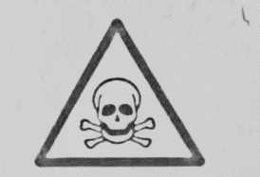
Figure 1
- What is the interpretation for the Hazard symbol drawn above?
- Harmful/ irritant substance.
- Flammable substance.
- Corrosive substance.
- Toxic substance.

Figure 2 below is a graph. Use it to answer the question that follows. 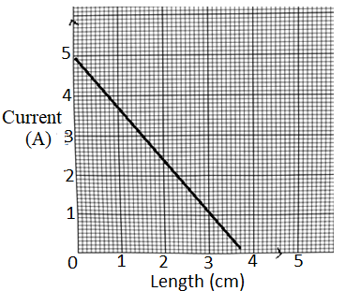
Figure 2

- What is the relationship between electric current and length of a wire?
- As length of a wire increases electric current decreases.
- As electric current decreases, length of a wire decreases.
- As length of a wire increases, electric current increases.
- As length of a wire decreases, electric current increases

- Figure 3 below is circuit diagram showing three cells connected in parallel. If each cell has a voltage of 1.5V, find total voltage in the circuit.

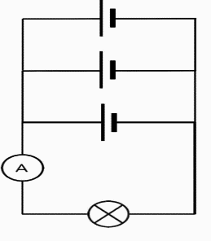
- 1.5v
- 3.0v
- 4.5v
- 0v

- The voltage and current through a device in a circuit are 10V and 2A respectively. Calculate resistance of the device.
- 20ohms
- 5 ohms
- 0.2ohms
- 5 joules

Figure 4 shows an effect of force. Use the information to answer question 11
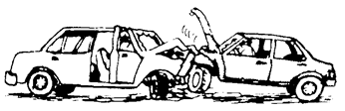
Figure 4
Identify the effect of force shown in the figure
- Moves stationary bodies
- Increases the speed of the moving bodies
- Changes the shape of the bodies
- Decreases the speed of moving bodies

- The effect of electric current associated with a filament wire in a bulb when is on.
- Light effect
- Magnetic effect
- Heating effect
- Chemical effect
- Which of the following is not a set of luminous sources of light?
- Sun, torch with no batteries, candle flame
- Sun, torch that is on, candle flame
- Candle flame, burning plastic, torch that is on
- Sun, burning paper, torch that is on

- Name the subatomic particles that are found inside the nucleus of an atom.
- Electrons and protons
- Electrons and neutrons
- Protons, electrons and neutrons
- Protons and neutrons.

Section B. (50 marks)
Answer all questions in the spaces provided.

- a. Explain why temperature remain constant when ice is melting? ____________________________________________________________________________________________________________________________________________________________________________________________________________________________________________________________ (2 marks)
b.Figure 5 is a swinging pendulum from point A to point C and then back to point A.
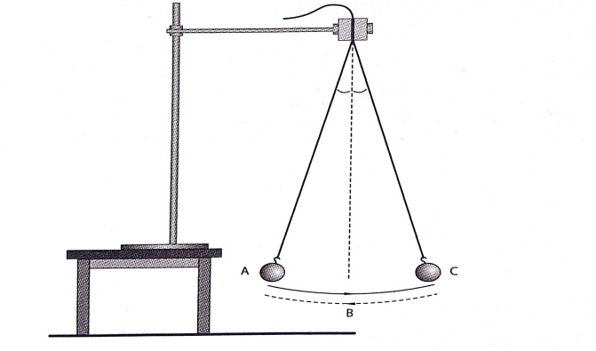
(i). Describe the energy changes that take place as the bob moves from point A to C through the resting point B. __________________________________________________________________________________________ (1 mark)
(ii). In which position does the bob have:
1. Least potential energy? __________________________________________________________________________________________ (1 mark)
2. Maximum kinetic energy? __________________________________________________________________________________________ (1 mark)
22. a. Give two differences between mass and weight. ________________________________________________________________________________________________________________________________________________________________________________________________________________________________________________________________________________________________________________________________________________________________________ (2 marks)
b. Find the weight of an object on the moon if it weighs 300 N on the earth.

- marks)
- a. State the law of conservation of energy. ________________________________________________________________________________________________________________________________________________________________________ (1 mark)
- How much potential energy will a 1000g mass gain if it is raised 25 m above the ground?

(3 marks)
c. What is the SI unit of work done? ______________________________________________________________________________
(1 mark)
- Figure 6 is a diagram showing identical bulbs connected in circuits X and Y.
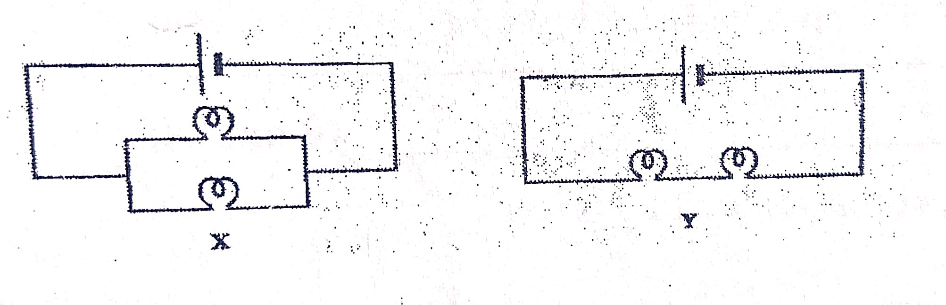
a. In which circuit would bulbs light more brightly? __________________________________________________________________________________________ (1 mark)
b. Explain your answer in to. 24 (a) ______________________________________________________________________________________________________________________________________________________________________________________________________________________________________________________________________________ (2 marks)
c. What would be the impact of adding more bulbs in circuit Y? ____________________________________________________________________________________________________________________________________________________________________________________ (1 mark)
d. Explain your answer to 24. (c). ______________________________________________________________________________________________________________________________________________________________________________________________________________________________________________________________________________ (2 marks)

e. Which circuit would be suitable for wiring a house? Explain? ____________________________________________________________________________________________________________________________________________________________________________________ (2 marks)
- Draw two magnets to show direction of magnetic field lines when south poles face each other.

(2 marks)
- a. State any two advantages of using machines. ________________________________________________________________________________________________________________________________________________________________________
(2 marks)
b. A builder mixed 10 g of cement of volume 2.5 cm³ and 30 g of sand and volume 17.5 cm³.
Calculate the average density of the mixture.

(3 marks)
- a. Mention any two devices that make use of electromagnets. ________________________________________________________________________________________________________________________________________________________________________
(2 marks)
b. Explain why a floating object sinks when the temperature of the liquid is raised. ____________________________________________________________________________________________________________________________________________________________________________________________________________________________________
(3 marks)
- a. What is the difference between heat and temperature? ____________________________________________________________________________________________________________________________________________________________________________________________________________________________________________________________
(2 marks)
b. Figure 7 below shows an experiment on conduction of heat. Use it to answer questions below
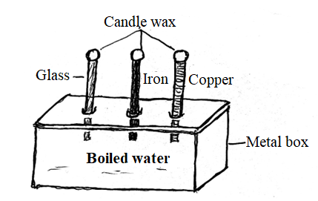

Results: The piece of candle wax on top of copper rod melted first and the
piece of candle wax on top of glass rod melted last.
    - What is the aim of the experiment? _________________________________________________________________________________ (1 mark)
    - Draw the conclusion of this experiment.
______________________________________________________________________________________________________________________________________________________________________ (1 mark)
c. What is the effect of increasing cells arranged in parallel on the brightness
of the bulb? ________________________________________________________________________________________________________________________________________________________________________ (1 mark)
- a. State one way of charging objects. ________________________________________________________________________________________________________________________________________________________________________ (1 marks)
- State the principle of moments. __________________________________________________________________________________________________________________________________________________________________ (2 marks)
30. a. Define specific heat capacity. ____________________________________________________________________________________ ____________________________________________________________________________________ (1 marks)
b. Calculate the amount of heat required to raise temperature of 2.5 Kg of aluminium from 20⁰C to 40⁰C if the specific heat capacity of aluminium is 900J/(KgK)

- marks)
c.Table 1 shows the specific heat capacities of some liquids A, B and C. Use the information to answer questions that follow.
Substance | Specific heat capacity J/kgK
A | 140
B | 4200
C | 2000
Table 2
(i).Which liquid can best be used as an engine coolant? _________________________________________________________________________________________ (1 mark)
(ii). Give a reason for your answer in 28 b.(i) ____________________________________________________________________________________________________________________________________________________________________________________ (2 marks)
(iii). Which liquid can best be used in a liquid in glass thermometer?
__________________________________________________________________________________________
(1 mark)
(iv). Give a reason for your answer in 28. b. (iii)
____________________________________________________________________________________________________________________________________________________________________________________ (2 marks)
SECTION C. (30 marks)
Answer all questions in this section in the spaces provided.
- a. Explain how a Periscope works. ________________________________________________________________________________________________________________________________________________________________________________________________________________________________________________________________________________________________________________________________________________________________________________________________________________________________________________________________________________________________________________________________________________________________________________________________________________________________________________________________________________________________
(5 marks)
b. Describe how a lightning conductor works to protect buildings from lightning. ________________________________________________________________________________________________________________________________________________________________________________________________________________________________________________________________________________________________________________________________________________________________________________________________________________________________________________________________________________________________________________________
(5 marks)
- a. Explain how volume of an irregular stone can be determined using water, measuring cylinder and a string. ____________________________________________________________________________________________________________________________________________________________________________________________________________________________________________________________________________________________________________________________________________________________________________________________________________________________________________________________________________________________________________________________________________________________________________________________________________
(5 marks)
b. Describe an experiment that could be carried out to show that electric current has a chemical effect. ________________________________________________________________________________________________________________________________________________________________________________________________________________________________________________________________________________________________________________________________________________________________________________________________________________________________________________________________________________________________________________________________________________________________________________________________________________________________________________________________________________________________ (5 marks)
- a. Describe an experiment to show that when different metals are heated equally they expand with different amounts. ________________________________________________________________________________________________________________________________________________________________________________________________________________________________________________________________________________________________________________________________________________________________________________________________________________________________________________________________________________________________________________________ (5 marks)
  - With the aid of a well labelled, explain how sea breeze occurs.

________________________________________________________________________________________________________________________________________________________________________________________________________________________________________________________________________________________________________________________________________________________________________________________________________________________________________________________________________________________________________________________
. (5 marks)
END OF QUESTION PAPER

